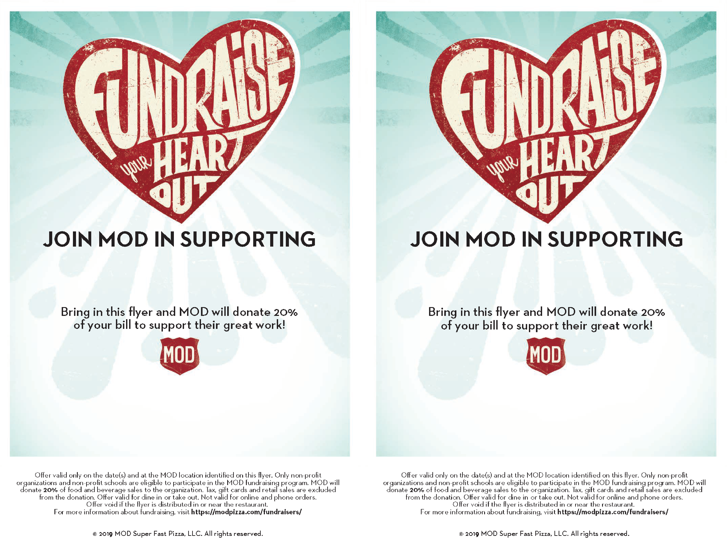

**Mechanicsville Volunteer Rescue Squad**

**Thursday, February 6, 2020**

**5pm-8pm**

**MOD PIZZA**

**St. Mary’s Market Place, California MD**

**RSVP at:** <https://www.groupraise.com/events/130424>

**Mechanicsville Volunteer Rescue Squad**

**Thursday, February 6, 2020 5pm-8pm**

**MOD PIZZA**

**St. Mary’s Market Place, California MD**

**RSVP at:** <https://www.groupraise.com/events/130424>